1978 D
The postulates of the Bohr model of the hydrogen atom can be stated as follows:
(I) The electron can exist only in discrete states each with a definite energy.
(II) The electron can exist only in certain circular orbits.
(III) The angular momentum of the electron is nh/2π where n is any positive integer.
(IV) Radiation is emitted by the atom only when an electron makes a transition from a state of higher energy to one of lower energy.
(a) State whether each of these postulates is currently considered to be correct, according to the wave mechanical description of the hydrogen atom.
(b) Give the wave mechanical description that has replaced one of the postulates now considered to be incorrect.
Answer:
(a) I. Correct III. (Correct)*
II. Incorrect IV. Correct
*Postulate III is not correct in a precise interpretation. The orbital angular momentum is now indexed by the quantum number 1 rather than by n, the principal quantum number. However, the postulate III statement above does not clearly identify n as the principal quantum number. Perhaps because of this ambiguity and perhaps because of the presentation in some texts, candidates called postulate III correct. The requirements of Part (b) for postulate III (that is, giving the wave-model alternative) is clearly beyond the scope of AP Chemistry. (The Chief Reader reports that he knows of no candidate who lost points as a result of this interpretation, which was used in the grading.)
(b) The wave-mechanical description of postulate II: Electron-cloud or charge distribution in contrast to “orbits”.
Interpretation of electron location in terms of high probability.
Spherical distribution for s-states but not for others. Or, electron locations standing waves with charge density waves equal to Ψ².

1980 D
(a) Write the ground state electron configuration for an arsenic atom, showing the number of electrons in each subshell
(b) Give one permissible set of four quantum numbers for each of the outermost electrons in a single As atom when it is in its ground state.
(c) Is an isolated arsenic atom in the ground state paramagnetic or diamagnetic? Explain briefly.
(d) Explain how the electron configuration of the arsenic atom in the ground state is consistent with the existence of the following known compounds: Na₃As, AsCl₃, and AsF₅.
Answer:
(a) 1s² 2s²2p⁶ 3s²3p⁶3d¹⁰ 4s²4p³ or
[Ar] 3d¹⁰ 4s²4p³
(b) 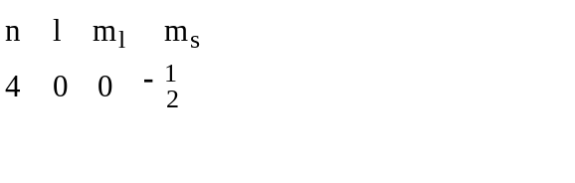
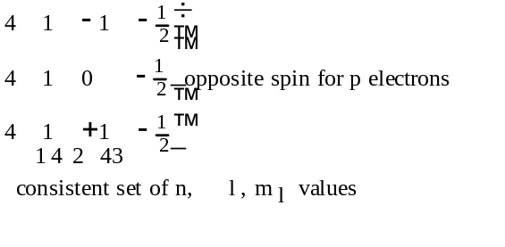
(c) Paramagnetic. There are 3 unpaired 4p electrons.
(d) An As atom can accept 3e- from electropositive Na atoms to give As atom a pseudo-Kr electron configuration. Ionic Na₃As results.
An As atom share 3e- for a share of an electron from each of 3 Cl atoms to get pseudo-Kr configuration for As atom in covalent AsCl₃.
An As atom can share all 5 valence electrons by using 4d - as well as 4s and 4p- orbitals (either through M.O.’s or L.C.A.O. hybrids) to give covalent AsF₅.

1981 D
The emission spectrum of hydrogen consists of several series of sharp emission lines in the ultraviolet (Lyman series) in the visible (Balmer series) and in the infrared (Paschen series, Brackett series, etc.) regions of the spectrum.
(a) What feature of the electronic energies of the hydrogen atom explains why the emission spectrum consists of discrete wavelength rather than a continuum wavelength?
(b) Account for the existence of several series of lines in the spectrum. What quantity distinguishes one series of lines from another?
(c) Draw an electronic energy level diagram for the hydrogen atom and indicate on it the transition corresponding to the line of lowest frequency in the Balmer series.
(d) What is the difference between an emission spectrum and an absorption spectrum? Explain why the absorption spectrum of atomic hydrogen at room temperature has only the lines of the Lyman series.
Answer:
(a) Any of the following:
Quantized energy levels. Discrete energies.
Wave properties of electron result in discrete energy state.
(b) An electron in an excited-state atom can go to any of several lower energy states.
The lines in each series represents shifts from several higher energy states to a single lower energy state, identified by the same principal quantum number or energy.
(c)
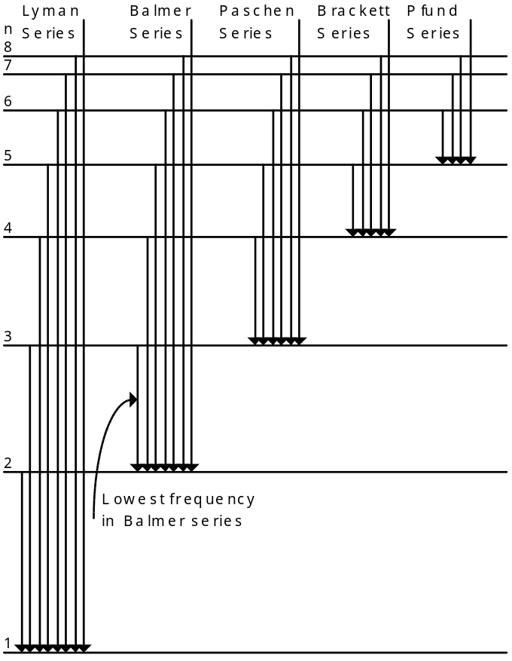
(d) Emission spectra obtained when electrons in excited atoms drop to lower energy levels.
Absorption spectra obtained when electrons in atoms in ground (or lower energy) state absorb electromagnetic radiation and move to higher energy states.
H atoms at 25°C are in lowest electronic energy state (n = 1) and so the only absorptions will result from electrons moving from n = 1 to higher levels.

1983 C
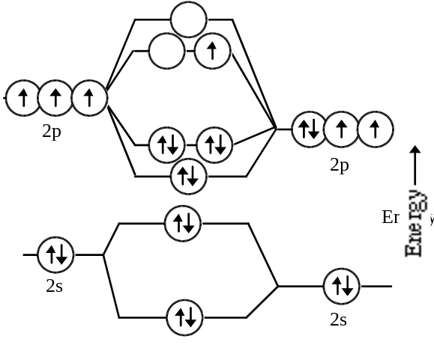
Atomic Orbitals for N Atomic Orbitals for O
The diagram above represents the molecular-orbital energy-level diagram for the NO molecule.
(a) Draw an analogous diagram for NO⁺ and one for NO⁻. Label the molecular orbitals.
(b) On the basis of these diagrams, compare the bond strengths, the bond lengths, and the bond orders for NO⁺ and NO⁻.
(c) Which, if any, of these two species is paramagnetic? Explain your reasoning.
Answer:
(a) NO⁺, as above, less the topmost electron.
NO⁻, as above, plus another unshared electron.
(b) Bond order:n NO⁺ = 3, NO⁻ = 2
Or, bond order for NO⁺ > bond order NO⁻
Bond length in NO⁺ shorter than in NO⁻
Bond strength in NO⁺ > bond strength in NO⁻
(c) NO⁻ is paramagnetic since Π* orbitals are degenerate so that electrons in these orbitals are unpaired.

1984 C
Discuss some differences in physical and chemical properties of metals and nonmetals. What characteristic of the electronic configurations of atoms distinguishes metals from nonmetals? On the basis of this characteristic, explain why there are many more metals than nonmetals.
Answer:
Physical properties:
metals non-metals
melting points rel. high rel. low
elec. conductivity good insulators
luster high little or none
physical state most solids gases, liq. or solids
[etc.]
Chemical properties:
metals non-metals
redox agents reducing oxid. or reducing
electropositive electronegative
oxides basic or amphoteric acidic
react with nonmetals metals & non-metals
[etc.]

Electron configurations: Metals: Valence electrons in s or d sublevels of their atoms. (A few heavy elements have atoms with one or two electrons in p sublevels.) Nonmetals: Valence electrons in the s and p sublevels of their atoms.
There are more metals than nonmetals because filling d orbitals in a given energy level involves the atoms of ten elements and filling the f orbitals involves the atoms of 14 elements. In the same energy levels, the maximum number of elements with atoms receiving p electrons is six.

1987 D
Use the details of modern atomic theory to explain each of the following experimental observations.
(a) Within a family such as the alkali metals, the ionic radius increases as the atomic number increases.
(b) The radius of the chlorine atom is smaller than the radius of the chloride ion, Cl⁻. (Radii : Cl atom = 0.99Å; Cl⁻ ion = 1.81 Å)
(c) The first ionization energy of aluminum is lower than the first ionization energy of magnesium. (First ionization energies: ₁₂Mg = 7.6 ev; ₁₃Al = 6.0 ev)
(d) For magnesium, the difference between the second and third ionization energies is much larger than the difference between the first and second ionization energies. (Ionization energies for Mg: 1st = 7.6 ev; 2nd = 14 ev; 3rd = 80 ev)
Answer:
(a) The radii of the alkali metal ions increase with increasing atomic number because the outer principal quantum number (or shell or energy level) is larger. OR
(1) There is an increase in shielding. (2) The number of orbitals increases.
(b) The chloride ion is larger than the chlorine atom because - (any of these)
(1) the electron-electron repulsion increases.
(2) the electron-proton ratio increases.
(3) the effective nuclear charge decreases.
(4) shielding increases.
(c) The first ionization energy for Mg is greater than that for Al because - (either of these)
(1) the 3p orbital (Al) represents more energy than the 3s orbital (Mg) represents.
(2) the 3p electron in an Al atom is better shielded from its nucleus than a 3s electron in a Mg atom.
(3) [half credit] a 3p electron is easier to remove than a 3s electron.
(d) In a Mg atom, the first two electrons lost are removed from the 3s orbital whereas the 3rd electron comes from a 2p orbital; a 2p orbital is much lower in energy than the 3s is; so more energy is needed to remove a 2p electron.

1987 D
Two important concepts that relate to the behavior of electrons in atom systems are the Heisenberg uncertainty principle and the wave-particle duality of matter.
(a) State the Heisenberg uncertainty principle as it related to the determining the position and momentum of an object.
(b) What aspect of the Bohr theory of the atom is considered unsatisfactory as a result of the Heisenberg uncertainty principle?
(c) Explain why the uncertainty principle or the wave nature of particles is not significant when describing the behavior of macroscopic objects, but it is very significant when describing the behavior of electrons.
Answer:
(a) [any one of these 3]
(1) It is impossible to determine (or measure) both the position and the momentum of any particle (or object or body) simultaneously.
(2) The more exactly the position of a particle is known, the less exactly the momentum or velocity of the particle can be known.
(3) (Δx(Δp) >= h or h or h/4π, where h = Plank’s constant, Δx = uncertainty in position, Δp = uncertainty in momentum.
(b) Bohr postulated that the electron in an H atom travels about the nucleus in a circular orbit and has a fixed angular momentum. With a fixed radius of orbit and a fixed momentum (or energy), (Δx)( Δp)<h/4. The Heisenberg principle is violated.
(c) [either of these 2]
(1) The wavelength of a particle is given by the DeBroglie relation λ = h/mv. For masses of macroscopic objects, h/m is so small for any v that λ is too small to be detectable. For an electron, m is so small that h/mv yields a detectable λ.
(2) The product of the uncertainties in position and velocity depends on h/m and since h is so small (h = 6.63×10⁻³⁴ J·s), unless m is very small as with the electron, the product of the uncertainties is too small to be detected.

1990 D
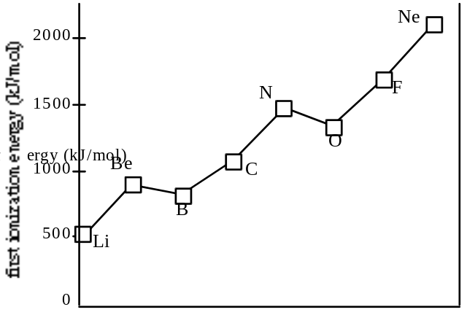
The diagram shows the first ionization energies for the elements from Li to Ne. Briefly (in one to three sentences) explain each of the following in terms of atomic structure.
(a) In general, there is an increase in the first ionization energy from Li to Ne.
(b) The first ionization energy of B is lower than that of Be.
(c) The first ionization energy of O is lower than that of N.
(d) Predict how the first ionization energy of Na compares to those of Li and of Ne. Explain.
Answer:
(a) Across the period from Li to Ne, the number of protons is increasing in the nucleus. Hence, the nuclear charge is increasing with a consequently stronger attraction for electrons and an increase in ionization energy.
(b) The electron ionized in the case of Be is a 2s electron, whereas, in the case of B it is a 2p electron. 2p electrons are higher in energy than 2s electrons because 2p electrons penetrate to the core to a lesser degree.
(c) The electron ionized in O is paired with another electron in the same orbital, whereas in N the electron comes from a singly-occupied orbital. The ionization energy of the O electron is less because of the repulsion between the two electrons in the same orbital.
(d) The ionization energy of Na will be less than those of both Li and Ne because the electron removed comes from an orbital that is farther from the nucleus and, therefore, is less tightly held.

1993 D
Account for each of the following in terms of principles of atom structure, including the number, properties, and arrangements of subatomic particles.
(a) The second ionization energy of sodium is about three times greater than the second ionization energy of magnesium.
(b) The difference between the atomic radii of Na and K is relatively large compared to the difference between the atomic radii of Rb and Cs.
(c) A sample of nickel chloride is attracted into a magnetic field, whereas a sample of solid zinc chloride is not.
(d) Phosphorus forms the fluorides PF₃ and PF₅, whereas nitrogen forms only NF₃.
Answer:
(a) Electron configurations:
Na: 1s² 2s²2p⁶ 3s¹ Mg: 1s² 2s²2p⁶ 3s²
One of the following explanations:
Octet/noble gas stability comparison
Energy difference explanation
Size difference explanation
and shielding/effective nuclear charge discussion.
(b) Correct direction and explanation of any one of the following: (1) shielding differences; (2) energy differences; (3) #proton/#electron differences
(c) Any one of the following:
(1) Ni unpaired electrons / paramagnetic; (2) Zn paired electrons / diamagnetic; (3) Ni unpaired electrons / Zn paired electrons; (4) Ni paramagnetic / Zn diamagnetic.
and orbital discussions / Hund’s Rule / Diagrams.
(d) Expanded octet or sp³d hybrid of phosphorous and lack of d orbitals in nitrogen. or
Nitrogen is too small to accommodate (bond) 5 fluorines or 5 bonding sites.

1994 D
Use principles of atomic structure and/or chemical bonding to answer each of the following.
(a) The radius of the Ca atom is 0.197 nanometer; the radius of the Ca²⁺ ion is 0.099 nanometer. Account for this difference.
(b) The lattice energy of CaO(s) is -3,460 kilojoules per mole; the lattice energy for K₂O(s) is -2,240 kilojoules per mole. Account for this difference.
 | Ionization Energy (kJ/mol)
 | First | Second
K | 419 | 3,050
Ca | 590 | 1,140
(c) Explain the difference between Ca and K in regard to
(i) their first ionization energies,
(ii) their second ionization energies.
(d) The first ionization energy of Mg is 738 kilojoules per mole and that of Al is 578 kilojoules per mole. Account for this difference.
Answer:
(a) The valence electrons in a calcium atom are the 4s². In a calcium ion these electrons are absent and the highest energy electrons are 3p, which has a much smaller size because the (-)/(+) charge ratio is less than 1 causing a contraction of the electron shell.
(b) Lattice energy can be represented by Coulomb’s law: lattice energy = k(Q₁Q₂),/r², where Q₁ and Q₂ are the charges on the ions, in CaO these are +2 and -2 respectively, while in K₂O they are +1 and -2. The r (the distance between ions) is slightly smaller in CaO, combined with the larger charges, accounts for the larger lattice energy.
(c) Electron arrangements: K = [Ar] 4s¹, Ca = [Ar] 4s²
(i) Potassium has a single 4s electron that is easily removed to produce an [Ar] core, whereas, calcium has paired 4s electrons which require greater energy to remove one.
(ii) a K⁺ ion has a stable [Ar] electron core and requires a large amount of energy to destabilize it and create a K²⁺ ion. Ca⁺ has a remaining 4s¹ electron that is more easily removed than a core electron, but not as easily as its first 4s electron.
(d) Electron arrangements,
Mg = [Ne] 3s², Al = [Ne] 3s², 3p¹
It is easier to remove a higher energy, single, unpaired 3p electron from the aluminum than to remove one electron from a lower energy, paired 3s orbital in magnesium.

1997 D
Explain each of the following observations using principles of atomic structure and/or bonding.
(a) Potassium has a lower first-ionization energy than lithium.
(b) The ionic radius of N³⁻ is larger than that of O²⁻.
(c) A calcium atom is larger than a zinc atom.
(d) Boron has a lower first-ionization energy than beryllium.
Answer:
(a) potassium’s valence electron is 4s¹ while lithium’s is 2s¹. potassium’s electron is shielded by more electrons than lithium and is therefore more easily removed at a lower energy.
(b) The addition of electrons to a neutral atom produces an anion that is significantly larger than its parent atom. Even though both ions are isoelectronic, there is a greater nuclear positive charge in the oxide ion causing its electrons to be more tightly pulled toward the nucleus.
(c) Even though a zinc atom contains 10 more electrons than calcium, these are all 3d electrons, filling an inner shell, not adding another larger one. There is a corresponding increase of 10 more protons for the zinc and this increase in nuclear charge pulls the electrons in more tightly and reducing its size.
(d) Boron’s last electron is 2p¹ and it receives the benefit of effective shielding by its completed 2s electrons. Thus it is easier to remove this electron.

1999 B
Answer the following questions regarding light and its interactions with molecules, atoms, and ions.
(a) The longest wavelength of light with enough energy to break the Cl–Cl boned in Cl2(g) is 495 nm.
(i) Calculate the frequency, in s–1, of the light.
(ii) Calculate the energy, in J, of a photon of the light.
(iii) Calculate the minimum energy, in kJ mol–1, of the Cl–Cl bond.
(b) A certain line in the spectrum of atomic hydrogen is associated with the electronic transition of the H atom from the sixth energy level (n = 6) to the second energy level (n = 2).
(i) Indicate whether the H atom emits energy or whether it absorbs energy during the transition. Justify your answer.
(ii) Calculate the wavelength, in nm, of the radiation associated with the spectral line.
(iii) Account for the observation that the amount of energy associated with the same electronic transition (n = 6 to n = 2) in the He+ ion is greater than that associated with the corresponding transition in the H atom.
Answer
(a) (i) c = λν ; ν = = =
= 6.06x1014 waves/sec
(ii) ΔE = hν
= (6.63x10–34 joule.s)(6.06x1014 s–1)
= 4.02x10–19 J
(iii) (4.02x10–19 J)(6.02x1023 mol–1) =
= 241,870 J = 242 kJ
(b) (i) emits energy. The n = 6 state is at a higher energy than n = 2, the electron must release energy go to the lower state.
(ii) E2 = = –5.445x10–19 J
E6 = = –6.05x10–20 J
ΔE = E6 – E2 = 4.84x10–19 J
OR
ΔE = –2.178x10–18 ( – ) J = 4.84x10–19 J
OR
λ = ; ν = =
= 7.30x1014 sec–1
λ = = = 4.11x10–7 m
OR
λ = =
= 411 nm
(iii) the He+ has a nuclear charge of 2+ vs H with a 1+, therefore, it has a stronger hold on the electron. This requires more energy for the electron to move to higher energy levels and when the electron moves from higher to lower energies, it releases more energy.

